**Name (netid):** Your Name (Your Netid)

**CS 441 - HW 2: Trees and MLPs**

Complete the claimed points and sections below.

**Total Points Claimed [ ] / 153**

1. Model Complexity with Tree Regressors
   1. Depth vs. Error plot [10] / 10
   2. Analysis [20] / 20
2. MLPs with MNIST
   1. Epochs vs Loss Table [10] / 10
   2. Learning Rates Results [10] / 10
   3. Model Selection and Results [20] / 20
3. Species Prediction
   * 1. Feature Analysis [10] / 10
     2. Simple Rule [10] / 10
     3. Model Design [10] / 10
4. Stretch Goals
   1. Improve MNIST classification [ ] / 20
   2. 2nd rule for species prediction [ ] / 5
   3. Positional Encoding [ ] / 25
   4. Submitted HW1 survey by Feb 12 [3] / 3
5. **Model Complexity with Tree Regressors**

Include your plot below.

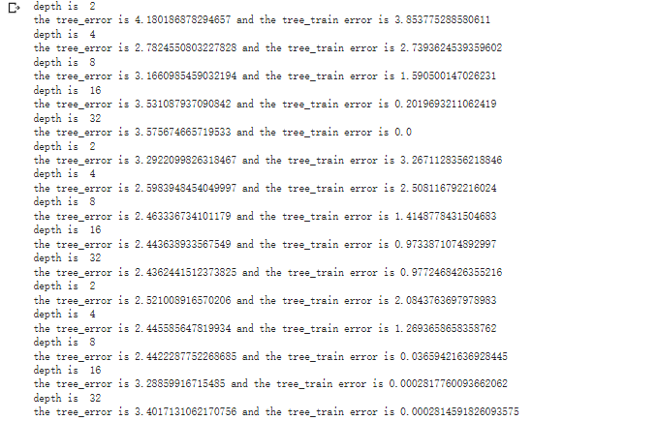

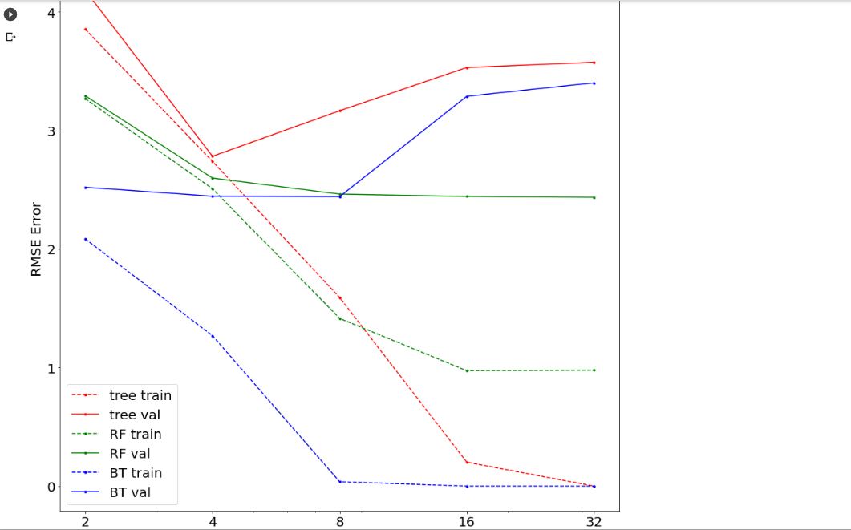

Analyze your results:

1. For a given max tree depth, which regressor model (tree, RF, BT) has the lowest bias (or is the most powerful)?

**Answer: the BT has the lowest bias and is the most powerful. Compared to other regressor models, its error is the first one close to 0 when the max tree depth is at 8.**

1. For regression trees, what tree depth achieves minimum validation error?

**Answer: at step 4, the regression trees achieve minimum validation error since they have an obvious dropping during this step.**

1. A model “overfits” when increasing the complexity increases the validation error. Which model is least prone to overfitting? Why?

**Answer: the regression tree is least prone to overfitting because the validation error of the regression tree decreases as the complexity increases.**

1. Do boost trees seem to perform better with smaller or larger trees? Why?

**Answer: based on the graph, when the complexity becomes larger, the boost trees perform worse than the RF and close to the tree. However, because the boost tress is the most powerful regressor model based on the graph. Therefore, boost trees could still perform better with less bias than other regressor models when it uses smaller trees.**

1. **MLPs with MNIST**

Using the default parameters, report your training and validation losses after the given number of epochs

|  |  |  |
| --- | --- | --- |
| # training epochs | Training Loss | Validation Loss |
| 25 | 0.1057 | 0.1313 |
| 50 | 0.0576 | 0.1018 |
| 100 | 0.0241 | 0.0937 |

Show the loss curves for at least 3 different learning rates

|  |  |
| --- | --- |
| Learning Rate | Loss Curve Plot |
| 1.0 |  |
| 0.01 |  |
| 0.001 |  |

Report the losses and errors for your best model here:

|  |  |  |
| --- | --- | --- |
| Training **Loss** | Validation **Loss** |  |
| 0.0178 | 0.0790 |  |

|  |  |  |
| --- | --- | --- |
| Training **Error** | Validation **Error** | Test **Error** |
| 0.25% | 2.20% | 2.26% |

**3. Species Prediction**

1. **Visualization of Features**

Report your visualizations (scatterplots) of different features and the relationships.

|  |  |
| --- | --- |
| Features | Visualization |
| Culmen length vs culmen depth | Based on the graph, we observe that Adelie will have a  Relatively large culmen depth but with a small culmen length.  Chinstrap and Gentoo both have the same culmen length. But,  Chinstrap will have relatively higher culmen depth on average. |
| Island vs body mass | Based on the graph, we observe that on the island of Torgersen,  Only Adelie is living there and their body mass is around 3000 to  Nearly 5000. On the Biscoe, we found that most of the Gentoo  have relatively higher body mass than the Adelie. On the  Dream, we find that Chinstrap has a range of body mass  Between 3000 and less to nearly 5000. We also find that some  Adelie lives in the Dream with a sparse body mass range. |

You may extend the table if you have more results

If you had to choose two features to make your species classification based on this analysis, which features would you choose?

1. **Simple rule to identify Gentoo**

Write down the simple two-part rule to identify Gentoo. Display your decision tree with labeled features and classes.

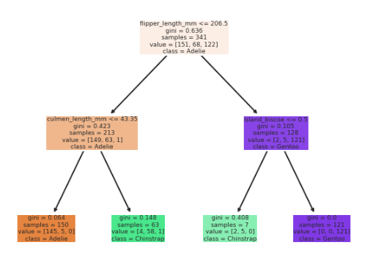

Based on the graph, we observe that when the flipper_length_mm is less or equal to 206.5. Then the species will be Adelie and Chinstrap. And then when the culmen_length_mm is less or equal to 43.35, the species is Adelie. Otherwise, the species is Chinstrap. When the flipper_length_mm is greater than 206.5, if the probability comes from island_biscoe is less or equal to 0.5, the species will be Chinstrap. Otherwise, the species will be Gentoo.

1. **Models**

Describe the model that achieves the best 5-fold cross-validation accuracy:

**Answer: I use 150 trees and a maximum depth of 8 for a random forest classifier to achieve the best 5-fold cross-validation accuracy. And the accuracy looks pretty good that it gets more than 99% and nearly close to 99.5%.**

5-fold Cross-Validation Accuracy: **99.41%**



**4. Stretch Goals**

1. **Improve MNIST Classification Performance using MLPs**

Report the classification val and test errors and details of your best method. Describe your approach and parameters. Feel free to change the MLP batch size, learning rate, number of epochs, hidden layer size, activation layer, or anything else.

**I try to use the learning rate as 0.0001 and use the 2 hidden layers which each is 512. The test error and validation error will be 0.1% better than what I did before, and the test error will still not be less or equal to 2%.**

**Validation Error: 1.9000%**

**Test Error: 1.6600%**

**I have used 3 hidden layers and each has 512 sizes. Also, I change the learning rate to 0.001 which will be a better one that could help me reduce the test error. The test error is 1.6600% which is lower than 2% and close to 1.5%.**

1. **Find a second simple rule to identify Gentoo**

Provide the second two-part rule here.

**I use the “entropy” criterion instead of the “gini” criterion in the first rule. For the second rule, I use the culmen_depth and the flipper_length_mm to check whether the species is Gentoo. The statement is that if culmen_depth <= 15 and the flipper_length_mm > 220, then it is Gentoo; Otherwise, it will be the other two species.**

1. **Positional encoding**

Show the image obtained by predicting directly from (x,y) and the image obtained by predicting from the positional encoding.

1. **HW1 Survey**

Don’t need to put anything here. Just claim the points if (and only if) you submitted the HW1 survey by end of Feb 12.

**Acknowledgments / Attribution**

List any outside sources for code or improvement ideas or “None”.